Arduino is an open-source electronics platform based on easy-to-use hardware and software. Arduino boards are able to read inputs - light on a sensor, a finger on a button, or a Twitter message - and turn it into an output - activating a motor, turning on an LED, publishing something online. You can tell your board what to do by sending a set of instructions to the microcontroller on the board.
Over the years Arduino has been the brain of thousands of projects, from everyday objects to complex scientific instruments. A worldwide community of makers - students, hobbyists, artists, programmers, and professionals - has gathered around this open-source platform, their contributions have added up to an incredible amount of accessible knowledge that can be of great help to novices and experts alike.

TASK ONE: Programming to blink LED lights at 1Hz.

- int LEDpin=13;
- void setup() {
- Serial.begin(9600);
- pinMode(LEDpin,OUTPUT);
- }
- void loop() {
- digitalWrite(LEDpin,HIGH);
- delay(500);
- digitalWrite(LEDpin,LOW);
- delay(500);
- }
In addition to programming, we need to connect a LED lamp to the 13th pin.
The LED lights up for 0.5 seconds and off for 0.5 seconds.In this loop it can blink at 1Hz.
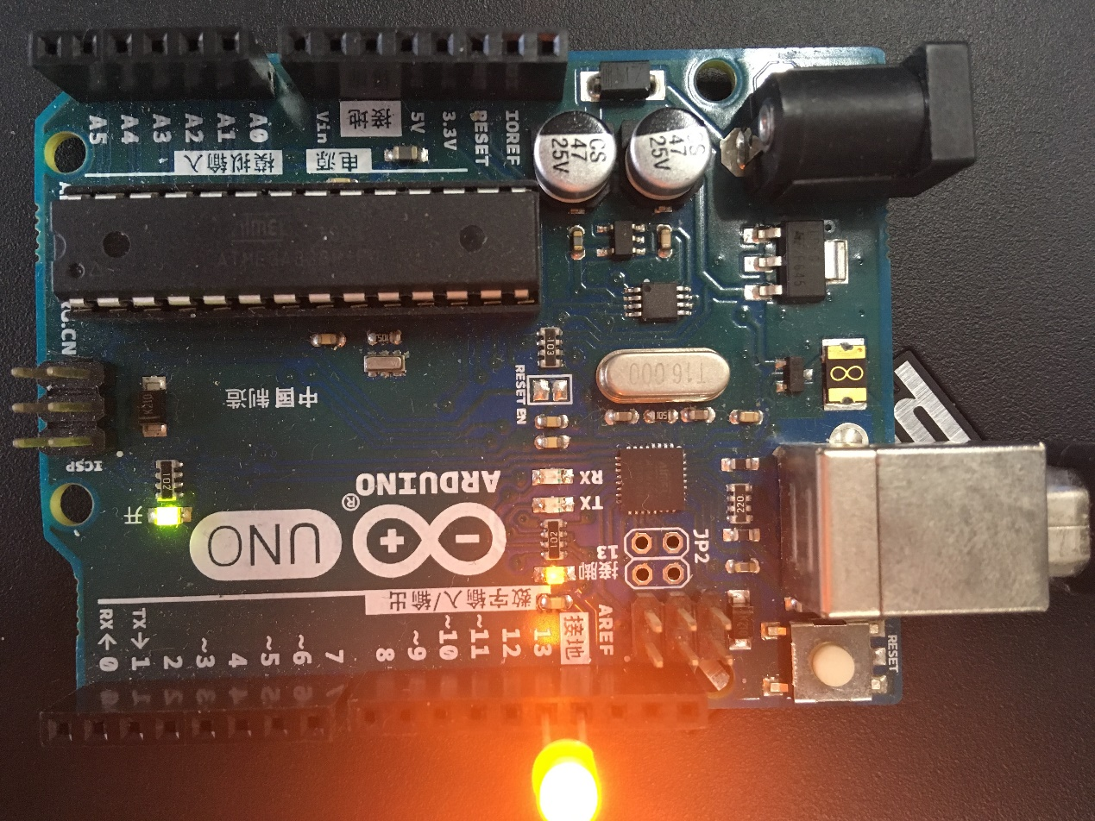
The complete program is in the "test" folder.
TASK TWO:The initial blink frequency is set to 1Hz, and the frequency input in the serial monitor is programmed to make the LED flash according to the frequency.
- #include <MsTimer2.h>
- int onoff = 0;
- int t0 = 500;
- void ONandOFF() {
- onoff += 1;
- digitalWrite(13, onoff % 2);
- //delay(300);
- }
- void setup() {
- pinMode(13, OUTPUT);
- Serial.begin(9600);
- MsTimer2::set(t0, ONandOFF);
- MsTimer2::start();
- }
- void loop() {
- //MsTimer2::set(500,turnOff);
- float msg;
- if (Serial.available())
- {
- //msg = 0;
- msg = Serial.parseFloat();
- Serial.print("输入频率：");
- Serial.println(msg);
- t0 = 500/msg;
- MsTimer2::stop();
- MsTimer2::set(t0, ONandOFF); //t0，设置时间
- MsTimer2::start();
- }
- }
Which need to use the Timer library <MsTimer2.h>, We need to add the library file to the "libraries" folder under the Arduino folder.
The initial frequency is set to 1Hz. The specific implementation is the same as the previous task.
In addition to this, we need to change the LED blinking frequency based on the data entered in the serial monitor.
In the loop, We need to determine if there is data entry in the buffer. If so, we will pass the data into the function(MsTimer2::set) after processing.

Methods
MsTimer2::set(unsigned long ms, void (*f)())
this function sets a time on ms for the overflow. Each overflow, "f" will be called. "f" has to be declared void with no parameters.
MsTimer2::start()
enables the interrupt.
MsTimer2::stop()
disables the interrupt.
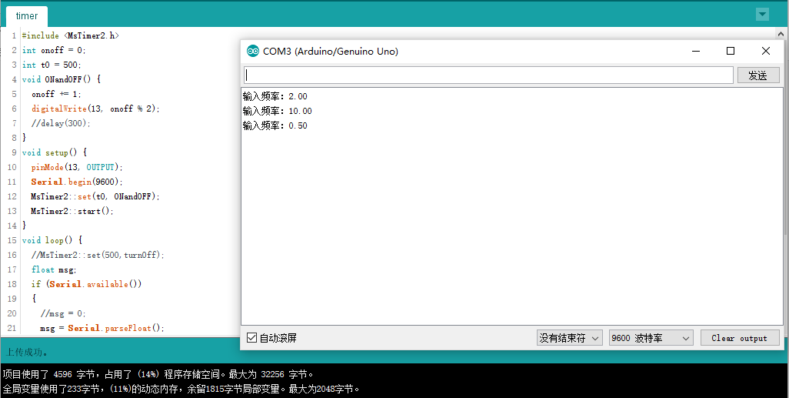
The complete program is in the "timer" folder.
TASK THREE: Use the task scheduler.
TaskScheduler library Download: https://github.com/arkhipenko/TaskScheduler
The method of adding a library is the same as the method described above.
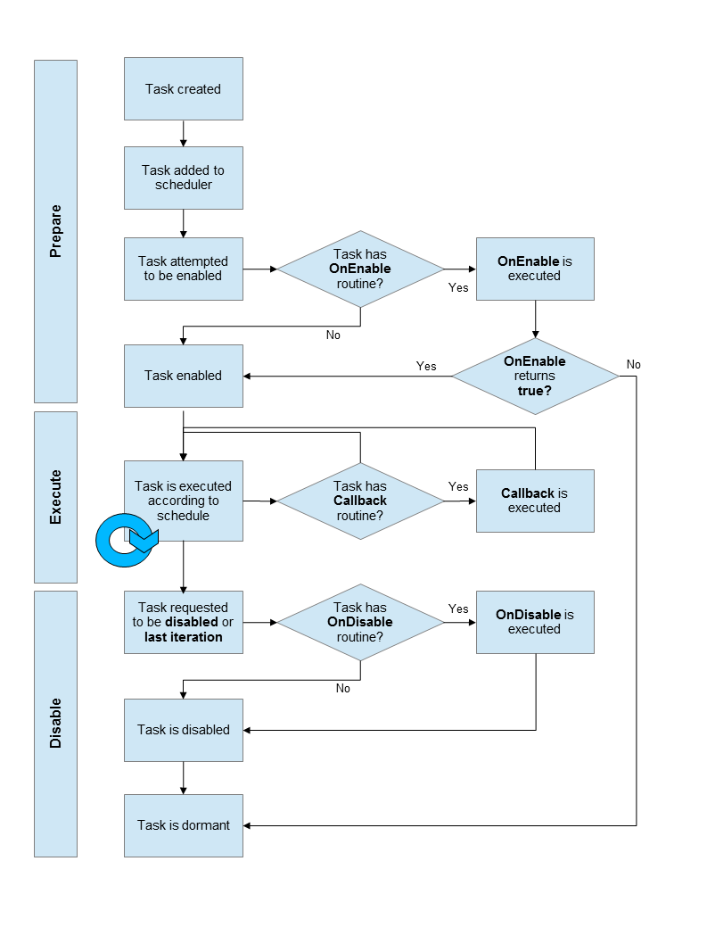
- #include <TaskScheduler.h>
- // Callback methods prototypes
- void t1Callback();
- void t2Callback();
- void t3Callback();

- //Tasks
- Task t4();
- Task t1(7000, 10, &t1Callback);
- Task t2(6000, TASK_FOREVER, &t2Callback);
- Task t3(8000, TASK_FOREVER, &t3Callback);

- Scheduler runner;

- void t1Callback() {
- Serial.print("t1: ");
- Serial.println(millis());//输出当前时间

- if (t1.isFirstIteration()) {
- runner.addTask(t3);
- t3.enable();
- Serial.println("t1: enabled t3 and added to the chain");
- }

- if (t1.isLastIteration()) {
- t3.disable();
- runner.deleteTask(t3);//删除任务
- t2.setInterval(500);//设置时间
- Serial.println("t1: disable t3 and delete it from the chain. t2 interval set to 500");
- }
- }
- void t2Callback() {
- Serial.print("t2: ");
- Serial.println(millis());
- }
- void t3Callback() {
- Serial.print("t3: ");
- Serial.println(millis());
- }

- void setup () {
- Serial.begin(115200);
- Serial.println("Scheduler TEST");

- runner.init();
- Serial.println("Initialized scheduler");

- runner.addTask(t1);//增加任务
- Serial.println("added t1");

- runner.addTask(t2);
- Serial.println("added t2");

- delay(5000);

- t1.enable();
- Serial.println("Enabled t1");
- t2.enable();
- Serial.println("Enabled t2");
- }

- void loop () {
- runner.execute();
- }

* TaskScheduler Test
* Initially only tasks 1 and 2 are enabled
* Task1 runs every 2 seconds 10 times and then stops
* Task2 runs every 3 seconds indefinitely
* Task1 enables Task3 at its first run
* Task3 run every 5 seconds
* Task1 disables Task3 on its last iteration and changed Task2 to run every 1/2 seconds
* At the end Task2 is the only task running every 1/2 seconds
The complete program is in the "Scheduler" folder.
TASK FOUR:Develop an Arduino's task manager library.

- #include "Task.h" // include this file to use this library
- void setup()
- {
- Serial.begin(115200);
- Sch.init(); // Initialize task scheduler
- /*
- * use Sch.addTask(task, start_time, period, priority) to add tasks
- * task - tasks to be scheduled
- * start_time - when the task starts (ms)
- * period - repeat period of the task (ms)
- * priority - 1: mormal priority, 0: high priority
- */
- Sch.addTask(task1,0,1000,1); //从第 0 毫秒开始 LED，每隔 1s,
- Sch.addTask(task2,20,500,1); //从第 20 毫秒开始 LED，每隔 0.5s,

- Sch.start(); // Start the task scheduler
- }
- void loop()
- {
- Sch.dispatchTasks();
- }
- // Put task to be scheduled below
- void task1()
- {
- Serial.print("t1:");
- Serial.println(millis());
- }
- int n = 0;
- void task2()
- {
- n++;
- if (n == 8)
- {
- Sch.deleteTask(0);
- Serial.println("delete task1");
- }
- Serial.print("t2:");
- Serial.println(millis());
- }

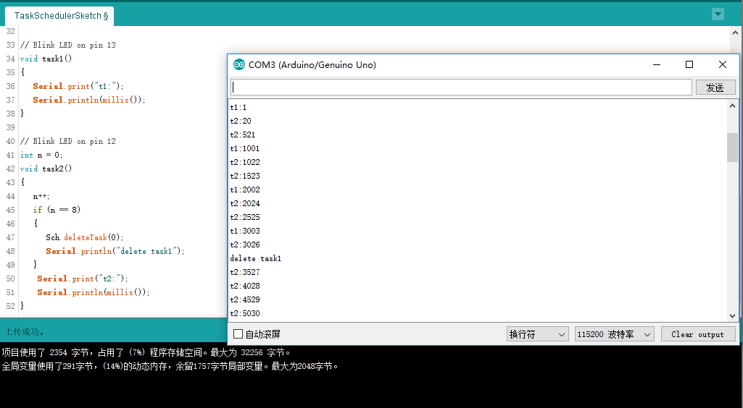
The program written therein needs to use the library of the task manager that has been developed. The task manager library is in the folder "Task".
Each task is represented in subscripted form. The following program comments detail the principle and meaning of the code. The following code shows how to add a task.
- /////////////////////////////////////////////////////////////////
- // unsigned char Schedule::addTask(void (*pFn)(), uint16_t del, uint16_t per, boolean co_op锛?// Add a task
- //
- // pFn - The task (function name) to be scheduled
- // del - The interval before the task is first executed
- // per - Repeat period of the task
- // If it is 0, it will run only once
- // co_op - If it is 1, it's a co-operative task
- // If it is 0, it's a pre-emptive task
- //
- // Return: Task IDs, which can be used in deleteTask() function
- //////////////////////////////////////////////////////////////////
- unsigned char Schedule::addTask(void (*pFn)(), uint16_t del, uint16_t per, boolean co_op)
- {
- uint8_t index = 0;

- // Find a gap in the array
- while ((g_Tasks[index].pTask != 0) && (index < MAX_TASKS))
- {
- index++;
- }

- if (index == MAX_TASKS)
- {
- // The task array is full.Can't add more tasks
- g_errorCode = ERROR_TOO_MANY_TASKS;
- return MAX_TASKS;
- }

- // Put the task into task array
- g_Tasks[index].pTask = pFn;

- g_Tasks[index].delay = del;
- g_Tasks[index].period = per;

- g_Tasks[index].co_op = co_op;

- g_Tasks[index].runMe = 0;

- return index; // Return task ID
- }

The following code shows how to delete a task. You can see that the corresponding subscript is zeroed when you delete a task.

- /////////////////////////////////////////////////////////////////
- // boolean Schedule::deleteTask(uint8_t taskIndex)
- // Delete a task
- //
- // taskIndex - ID of the task to be deleted
- //
- // Return:
- // RETURN_ERROR - Can't delete the task.
- // RETURN_NORMAL - Succeed in deleting the task
- //////////////////////////////////////////////////////////////////
- boolean Schedule::deleteTask(uint8_t taskIndex)
- {
- boolean returnCode;

- if (g_Tasks[taskIndex].pTask == 0)
- {
- // There is no task
- g_errorCode = ERROR_CANNOT_DELETE_TASK;
- returnCode = RETURN_ERROR; // Return an error code
- }
- else
- {
- returnCode = RETURN_NORMAL;
- }
- g_Tasks[taskIndex].pTask = 0;
- g_Tasks[taskIndex].delay = 0;
- g_Tasks[taskIndex].period = 0;

- g_Tasks[taskIndex].runMe = 0;

- return returnCode; // return status
- }
The complete program is in the "task" folder.

TASK FIVE:Combine Task Manager with "CommShell4Arduino"
( A Serial Shell for inteactively control the Arduino board)

The input of the genetic number in the serial monitor is like 1 1 0. The position determines which task function to use, where 1 represents the opening of the function and 0 represents the closing of the function. This makes it easy to call any of the known functions.
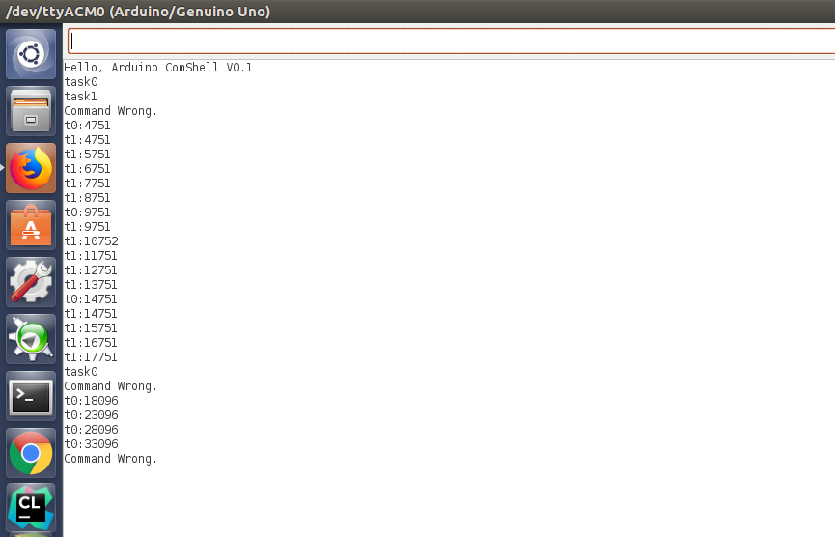

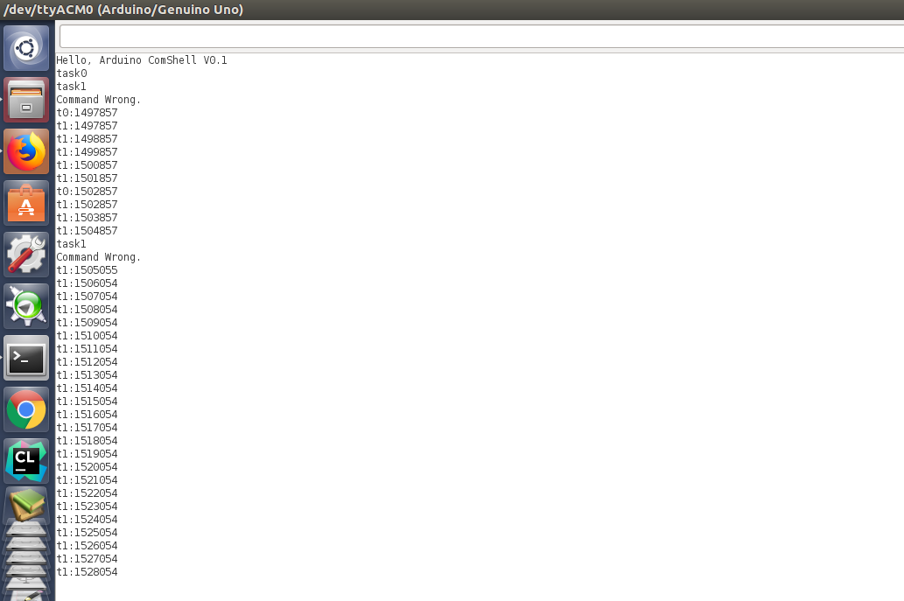
The above two figures demonstrate how to schedule the task. Enter the sequence 1 1 in the serial monitor to open task 0 and task 1, which will output the task execution time in the interface. When the (0 1) sequence is entered in the serial monitor, Task 0 is closed and Task 1 is still running. You can see in the interface that only task 1 is continuously outputting its execution time.
The complete program is in the "CommShell4Arduino-dev" folder.

